

**Batch: A-4 Roll No.: 16010422211 Experiment No.: 3**

**Aim:** To Design and Implementation of Different Arithmetic Circuits using Vlab. **___________________________________________________________________**

**Resources needed:** internet connection,

Access to- https://he-coep.vlabs.ac.in/exp/various-arithmetic-circuits/index.html

**Theory:**

**Explain following points in brief**

1. **Binary Adder – Subtractor**
2. **Half Adder**
3. **Full Adder**
4. **4 bit Binary Adder Subtractor**

**Explore the Theory and lab Manual in References section of the Vlab experiment**

**Procedure:**

1. Appear for Pretest and include the screenshot in write-up.
2. Design and Realize a Half Adder. Include scanned copy of design in write up.
3. Go through Procedure Tab.
4. Explore Simulator as per instructions in Procedure include screenshot of every circuit simulated in the writeup.
5. Appear for Posttest and include screenshot in write-up.
6. Create a document with screenshots mentioned above, Outcome and Conclusion.
7. Please note every document uploaded as Lab Writeup should be labelled as Exp_<No>_<RollNo.pdf

**___________________________________________________________________________**

**Observations and Results:**

*PRETEST:*

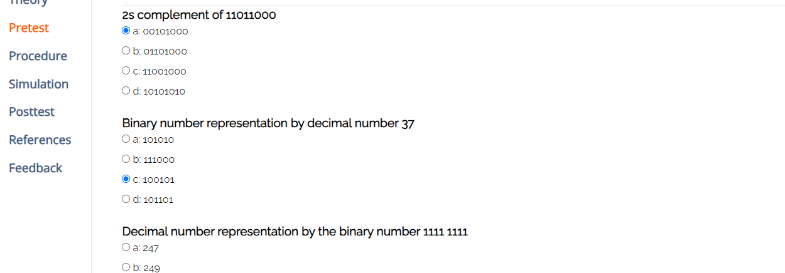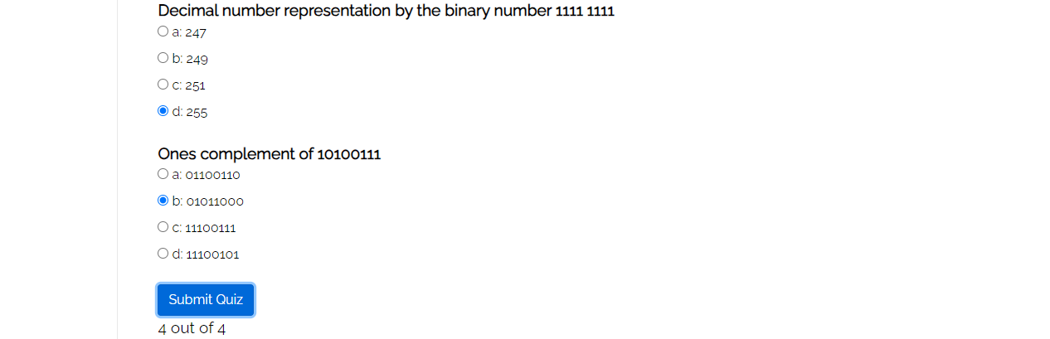

Design of Half Adder.

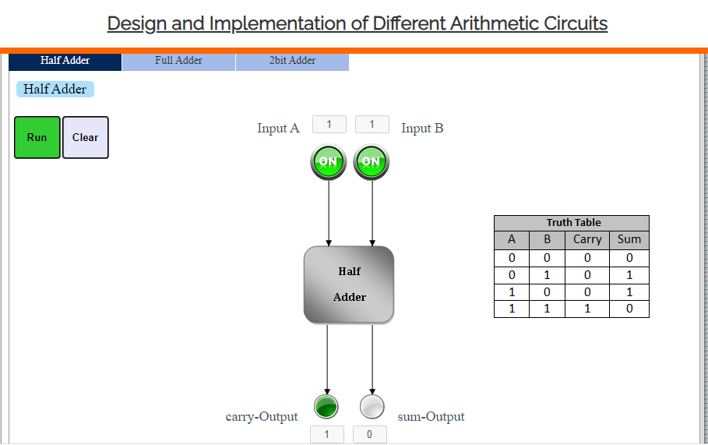

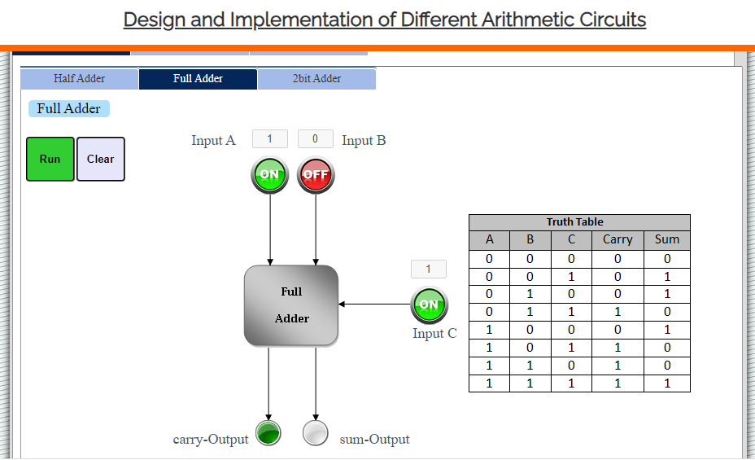

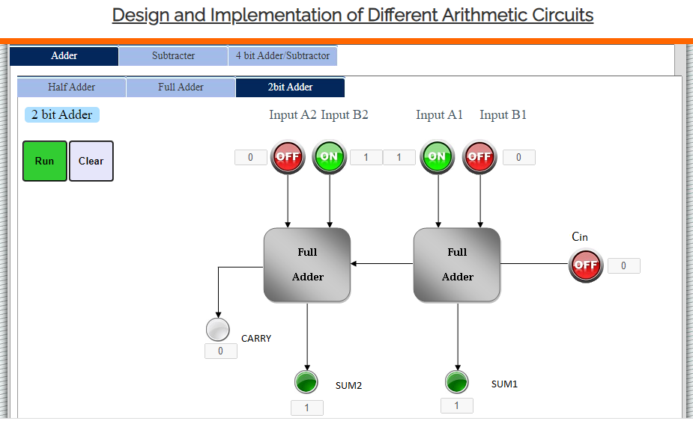

Observe and understand the simulated Binary Adders and Subtractors.

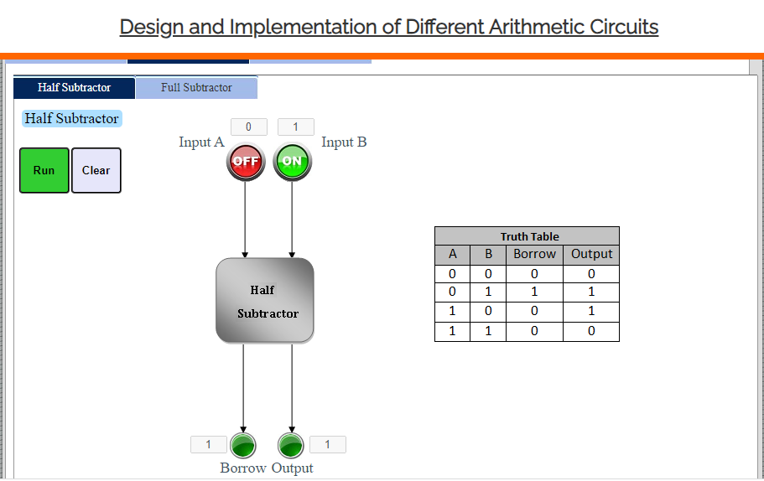

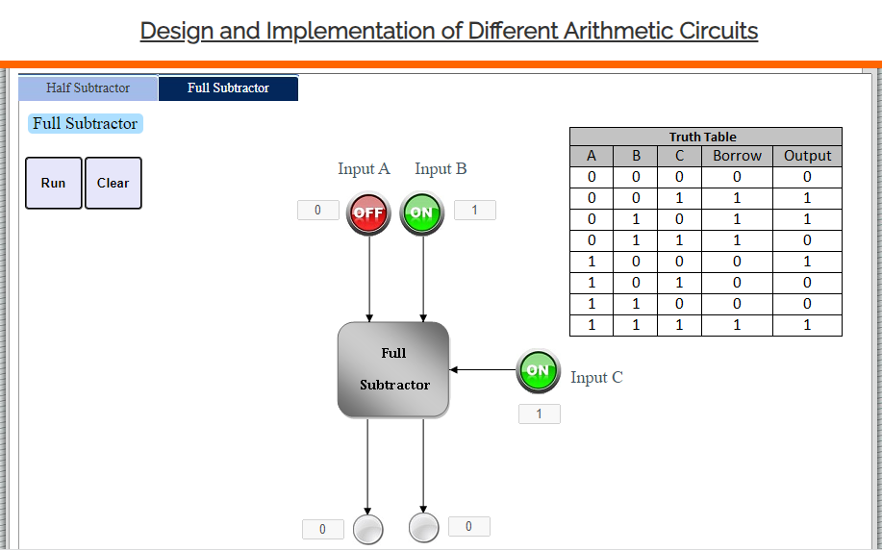

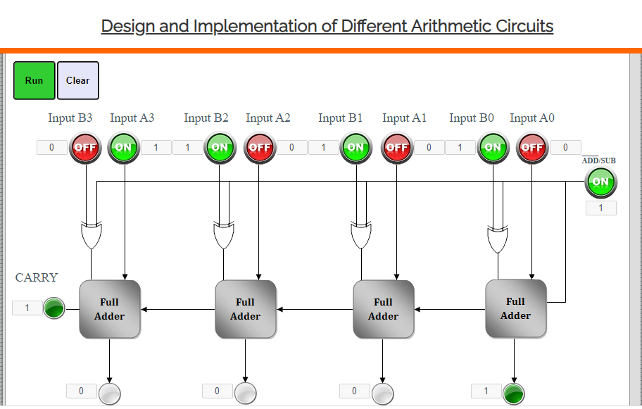

POSTTEST:

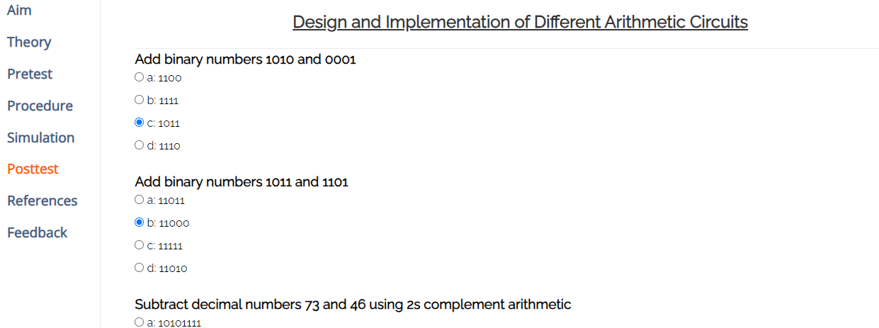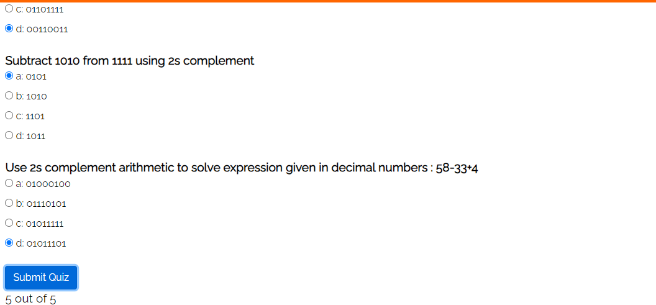

**Outcomes:** Understand the basic building blocks, techniques used in digital logic design.

**___________________________________________________________________________**

**Conclusion:** *Learned to Design and Implement different circuits using Vlab.*

**Grade: AA / AB / BB / BC / CC / CD /DD**

**Signature of faculty in-charge with date**

**___________________________________________________________________________**

**References:**

**Books/ Journals/ Websites:**

1. R. P. Jain, “Modern Digital Electronics”, Tata McGraw Hill.
2. <https://he-coep.vlabs.ac.in/exp/various-arithmetic-circuits/index.html>
3. https://he-coep.vlabs.ac.in/exp/various-arithmetic-circuits/images/Lab.Manual.Exp.arithmatic.ckt.pdf